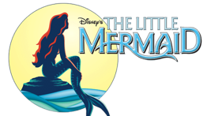 and MORE!
NEW – JULY SUMMER CAMP!
Singing and Dancing!
Does your child enjoy those 2 words?
If so, don't miss your spot in our Summer Camp!
Join Patty Corella and the staff of Corella Productions for one week of fun! This camp will be a studio presentation of songs from The Little Mermaid, Annie, Fiddler on the Roof, Peter Pan and more!!
Corella Productions Musical Theatre Summer Camp is for ages 4-8.
The program will run July 6th-10th from 1:00pm to 5:00 pm at Sovereign Ballet at 2539 W. 12th Street in Erie. Students may bring a snack!
Tuition for the week is $160.00 per child and is due on July 6th.
However please text 814-602-8221 to reserve your child's spot or to have questions answered! Space limited to 15 students.
_____________________________________________________________________________

Name of Student_________________________________________ Age_____ DOB ______
Address w/ City and Zip _______________________________________________________
Name of Parent(s)/Guardian(s)__________________________________________________
Email_________________________________________ Cell Phone______________________
Work Phone__________________________________

(Please check one)
______ I have attached a $160.00 check payable to Corella Productions for Summer Camp
______ Please charge $160.00 to the credit card listed below for Summer Camp

Credit card #: ________________________ Exp: __/___ CVV: ____ Zip Code: ______
Signature: __________________________________________________________

